SQL QUERIES TEST 2
Below are the details of Employees working for a software Company. (For questions from 1 to10) Create the table called EmpDetails with the below mentioned details.

Eid  (Primary Key) | Ename | DOB | Designation | Salary | DOJ
E101 | Suma | 29-Dec-89 | Designer | 20000 | 01-Apr-10
E102 | Amit | 10-Jan-95 | Programmer | 25000 | 18-Feb-18
E103 | Payal | 15-Aug-85 | Tester | 35000 | 13-Jun-11
E104 | Kiran | 20-Apr-90 | Programmer | 40000 | 7-Mar-14
E105 | Meenal | 29-May-83 | DBA | 50000 | 9-Dec-11
E106 | Sheila | 1-May-70 | Analyst | 60000 | 25-Sep-18
E107 | Swamy | 13-Jan-85 | Programmer | 45000 | 14-Feb-16
E108 | Sushma | 22-Dec-76 | DBA | 45000 | 31-Jan-12

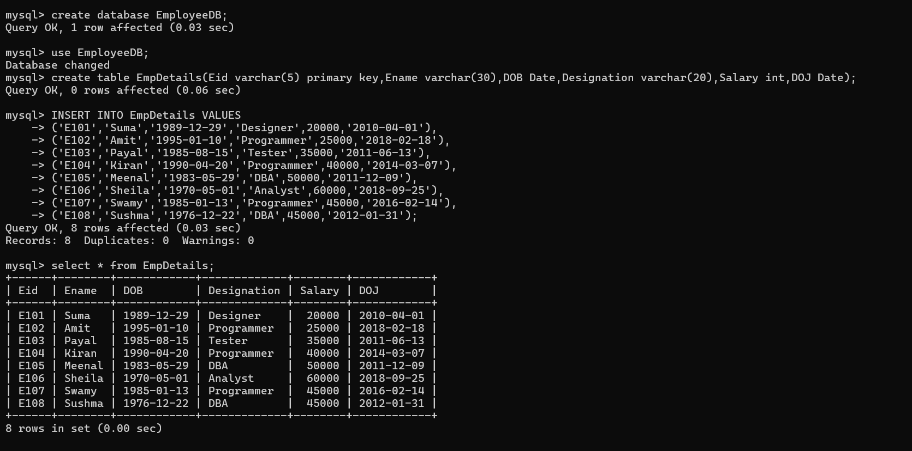

- Write sql query to display all the employees whose designation is Programmer.
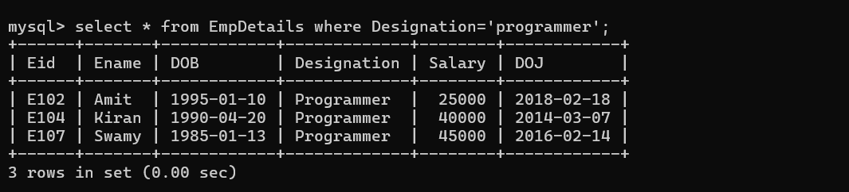

- Write sql query to display employees who have joined after 2014.

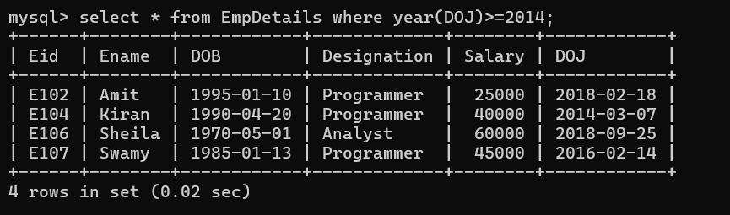

- Write sql query to display all the employees whose name ends with ‘a’.
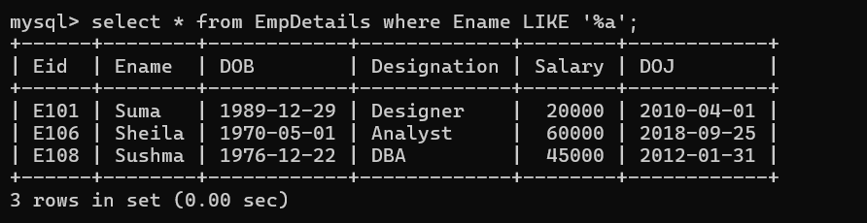

- Write sql query to display the total salary of all the employees whose designation is programmer.

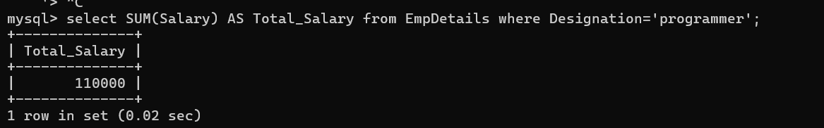

- Write sql query to display all the employee names in upper case.

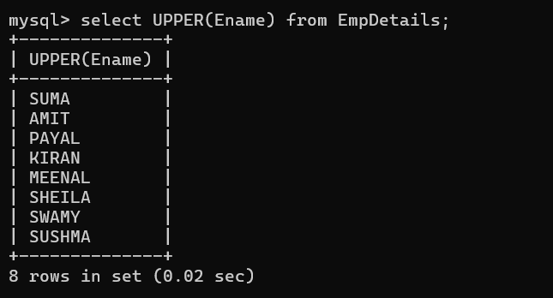

- Write sql query to display the details of the employee with highest experience.

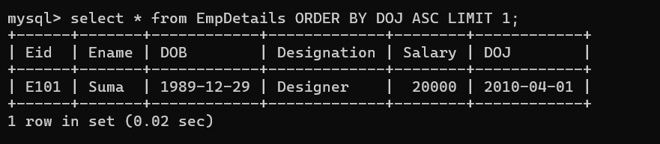

- Write sql query to display the details of the employees whose name contains ‘ee’.

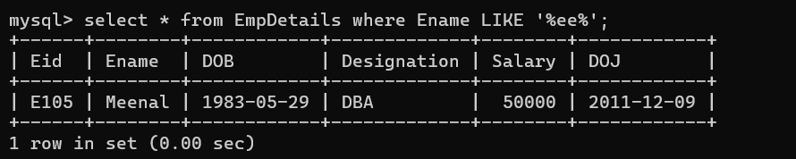

- Write sql query to increase the salaries of employees by 5000 whose designation is DBA.



- Write sql query to display the employees whose salary is more than the average salary of all the employees.

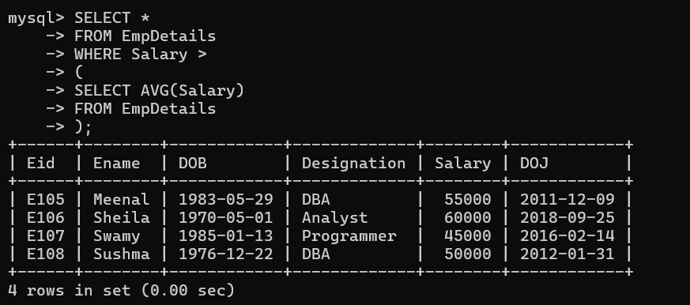

- Write sql query to display the record in the following format: xxxxxxxxx is working as xxxxxxxxxxxxxx with a Salary of Rs.xxxxxxxx
eg: Suma is working as Designer with a Salary of Rs. 20000

